Juvenile Salmon Migration Observations in the Discovery Islands and Johnstone Strait in 2018

Most out-migrating juvenile Fraser River sockeye (*Oncorhynchus* *nerka*), pink (*O.* *gorbuscha*), and chum (*O.* *keta*) salmon pass northwest through the Strait of Georgia, the Discovery Islands, and Johnstone Strait—a region of poor survival for juvenile salmon relative to the Strait of Georgia. To better understand the factors that are driving early marine survival through this region the Hakai Institute Juvenile Salmon Program monitors key aspects of this migration by capturing migrating salmon between May and July each year using a purse seine. Here we report on the 2018 migration in comparison to averages from our 2015–2018 time series. In 2018 sockeye, pink, and chum migration timing was not significantly different than time series averages. The median capture date in the Discovery Islands was May 23rd for sockeye, and June 12th for pink and chum. Pink salmon had the highest catch proportion and the highest average catch intensity in 2018 followed by chum and sockeye. Sockeye were longer than average in 2018 whereas pink and chum were smaller than average (all *p* < 0.001). In the Discovery Islands sea lice abundance was lower than average for sockeye, pink, and chum. In Johnstone Strait sea lice abundance was lower for chum but higher than average for sockeye and pink. Notably, there were no *Lepeophtheirus salmonis* sea lice observed in Johnstone Strait in 2018. Sea surface temperatures in the northern Strait of Georgia during the smolt migration period of 2018 were the warmest on record in the study period.

# Introduction

The first months after marine entry have been identified as a potentially critical period (Beamish and Mahnken 2001) for salmon stock recruitment, which may ultimately be responsible for inter-annual variability and long term declines in salmon stocks in British Columbia (Peterman et al. 2010; Beamish et al. 2012). Pathogens, parasites, predators and the impacts of climate change on food web dynamics have emerged as leading causes for the decline. The Hakai Institute Juvenile Salmon Program has been monitoring juvenile salmon migrations in the Discovery Islands and Johnstone Strait (Figure @ref(fig:map)) since 2015 in an effort to understand what factors may be influencing early marine survival of sockeye, pink, and chum (Hunt et al. 2018). This report summarizes migration timing, fish length, parasite loads, species composition, and sea-surface temperature observed from the first 4 years of this research and monitoring program. These estimates will provide the context from which to investigate questions and interpret results related to growth, survival, and the conditions salmon experience during their migration through this critical region.

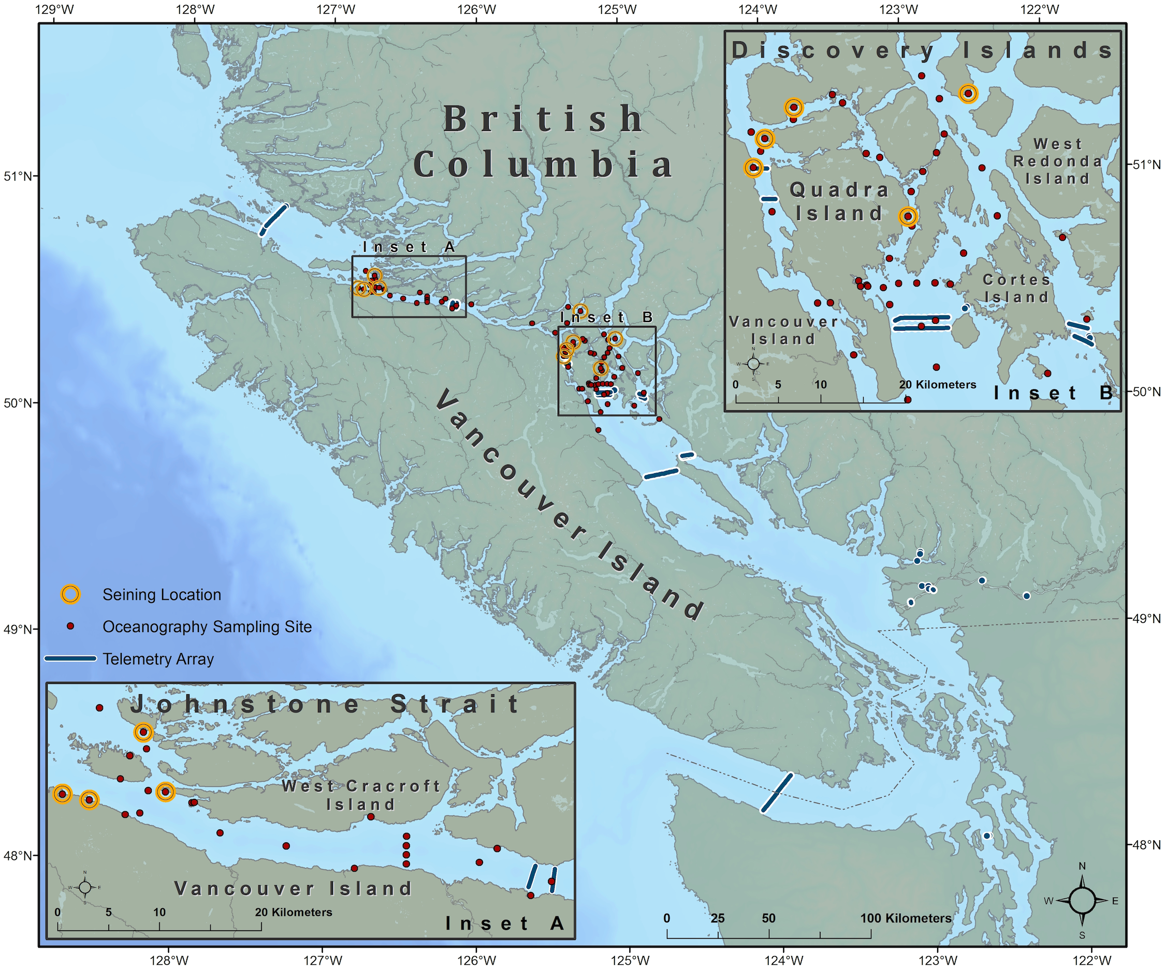

Sampling locations in 2018

# Methods

## Field methods

See Hunt et al. (2018) for a detailed description of field and lab methods. Briefly, juvenile salmon were collected weekly from the Discovery Islands and Johnstone Strait during their northward migration from the Strait of Georgia to Queen Charlotte Strait near northern Vancouver Island, British Columbia. Sampling was conducted from May to July each year beginning in 2015 using purse seine nets (bunt: 27 m x 9 m with 13 mm mesh; tow: 46 m x 9 m with 76 mm mesh). Near shore marine habitats where depth was > 10 m were sampled and sockeye (*Oncorhynchus nerka*), pink (*O. gorbuscha*), chum (*O. keta*) were effectively sampled and coho (*O. kisutch*), Chinook (*O. tshawytschya*) and Pacific herring (*Clupea pallasii*) were incidentally captured. All animal care was in accordance with Animal Care Guidelines under permit A16-0101. Temperature data were collected by deploying an RBR conductivity, temperature, and depth profiler to depths > 30 m at station QU39 (Figure @ref(fig:map)) in the northern Strait of Georgia.

## Data Analysis

Time series anomalies reported are in relation to the time series averages (2015-2018). The mean for each parameter of interest was calculated for all years combined, and the z-score was calculated for each parameter to determine the number of standard deviations away from the mean a given parameter was in each year. Measurements from the Discovery Islands and Johnstone Strait regions of the salmon migration were combined in analyses unless otherwise indicated. Only sites that were sampled in all years were used. All analyses were conducted using R (R Core Team 2017).

The peak migration date for each species was estimated by calculating the median date of capture in the Discovery Islands. This method was used because the period in which surveys and seines were conducted was the same each year and seines were always conducted before sockeye arrived and after sockeye disappeared. Often, however, the entire duration of the pink and chum migration through the Discovery Islands was not captured because their migration period is more protracted compared to sockeye. Cumulative abundance was calculated over a constrained period between May 1st and July 9th of each year. Seines from Johnstone Strait were excluded from the migration timing calculation so that timing indicates the migration through the Discovery Islands. Because very few pink are caught in odd-years, only even-years were included in the calculation of the pink time series average.

Catch intensity was calculated to provide a measure of inter-annual abundance for sockeye, pink, and chum. Catch intensity was defined as the average number of a species caught when > 1 of that particular species was caught, and when sockeye were also caught. In effect, catch intensity summarizes the abundance of each species in a community of co-migrating sockeye, pink, and chum when sockeye are present.

Species proportions were calculated by dividing the total number of each species caught, by the sum of all species caught that season. Only seines that caught sockeye were used in the calculation of species to represent the salmon community composition that co-migrate with sockeye. To test whether fork lengths from 2018 were significantly different than the time series an independent two-group t-test was conducted. Fork length distributions were visualized by calculating length frequency distributions using kernel density estimates from fork length data.

The prevalence, intensity, and abundance of *Caligus clemensi* and *Lepeophtheirus salmonis* sea lice parasites were calculated according to the definitions in Margolis et al. (1990). Naplius and chalimus life stages were not included in our analyses, only adult motile stages were analyzed. So few *L. salmonis* sea lice were observed that their counts were combined with *C. clemensi* and combined species parasite loads are reported.

The mean sea surface temperature (SST) was calculated from the top 30 m of the water column in May and June—the period during which salmon migrate through the region. To visualize temperature anomalies, a loess regression was applied to sea surface temperatures from all years to develop a model that represents the average seasonal trend. Deviations above or below the seasonal trend were coloured red or blue respectively to indicate the direction and magnitude of the anomaly.

# Results and Discussion

Most migration parameters were below average in 2018 except for sockeye length and SST (Figure @ref(fig:heatmap)). Interestingly, sockeye length tends to be the opposite anomaly compared to pink and chum which vary together.

Migration timing in the Discovery Islands in 2018 did not differ from the time series average by more than a week for sockeye, pink, or chum (Figure @ref(fig:migration-timing-plot)) (Table @ref(tab:migration-timing-table)). The peak migration date for sockeye in the Discovery Islands was on May 23, 5 days earlier than the time series average of May 28. The peak migration date for pink in the Discovery Islands was on June 12, 5 days earlier than the average of June 17. The peak migration date for chum in the Discovery Islands was on June 12, 3 days earlier than the average of June 15.

Sockeye catch intensity in 2018 was low relative to sockeye in previous years and relative to pink and chum in 2018 (Figure @ref(fig:catch-intensity-plot)). That sockeye catch intensity was low in 2018 is not surprising because 2016 brood year Shuswap or Chilko Lake sockeye are not as abundant in this cohort as they are in others. Pink catch intensity in 2018 was the highest of the four years measured. Pink out-migrants are more abundant on even years, the result of the odd-year dominant life-cycle of Fraser River pinks (Heard 1991), but 2018 catches indicate either good production or good survival in the early marine environment for pink salmon relative to 2016—the only other odd-year dominant brood year recorded by the Juvenile Salmon Program.

Pink salmon dominated the catch in the Discovery Islands and Johnstone in 2018 making up 51.5 % of the catch (Table @ref(tab:proportion-table)) while chum made up 32.6 % and sockeye 13.1 % (Figure @ref(fig:proportion-plot)). This was the first time in the time series that pink dominated the catch proportion.

Fish lengths varied between regions, species and year (Figure @ref(fig:length-plot)) though in 2018 sockeye were longer, pink were shorter, and chum were shorter than their respective time series averages in the Discovery Islands and Johnstone Strait combined. Sockeye length was 116.9 mm (Table @ref(tab:length-table)), which is 8.3 mm longer than the time series average (*p* < 0.0001, 95% CI 5.5 –11.2). Average pink lengths were 96.4 mm, which is 9.5 mm shorter than the time series average (*p* < 0.0001, 95% CI 11.8–7.2). Chum were on average 103.5 mm, which is 7.9 mm shorter than the time series average (*p* < 0.0001, 95% CI 9.9—5.8).

The abundance of motile sea lice in 2018 was the among the lowest recorded in the Discovery Islands time-series while Johnstone Strait parasite loads were average. (Figure @ref(fig:sealice-abundance-plot)). Notably, no *Lepeophtheirus salmonis* were detected on sockeye in Johnstone Strait, despite being present in the Discovery Islands. Pink salmon had higher sea lice abundance, prevalence, and intensity compared to the chum and sockeye time series average (Table @ref(tab:sealice-table)) in contrast to Patanasatienkul et al. (2013) where they found that the prevalence and intensity of sea lice was higher on chum than pink on early marine entrants in the Broughton Archipelago.

Sea-surface temperature in May and June during the juvenile salmon out-migration at QU39 in the northern Strait of Georgia was 0.28 degrees C warmer than average (Table @ref(tab:sst-table)) (Figure @ref(fig:sst-plot)). In the context of the last four last years 2018 was the warmest surface waters observed in the northern Strait of Georgia, despite 2015 SST along the BC coast breaking records for high temperatures (Chandler, King, and Boldt 2017).

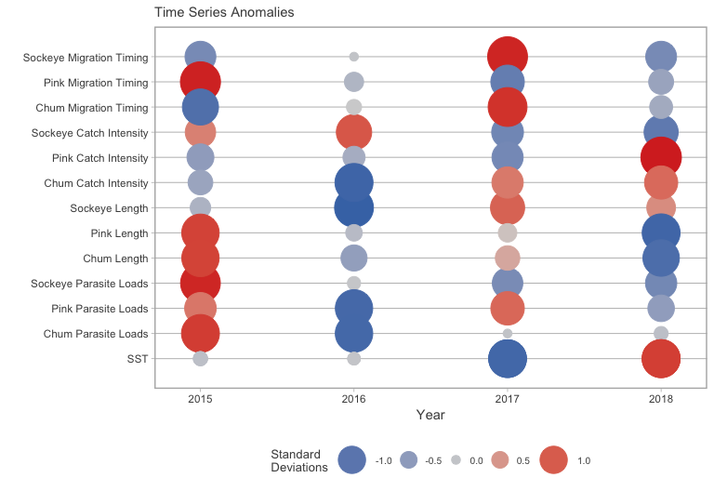

This heatmap indicates the number of standard deviations (z-score) from the time series average (2015-2018) for key migration parameters. Blue colour indicates less than average, grey indicates average, red indicates greater than average. Peak migration date is based on the median date of fish capture in the Discovery Islands. Length is based on the average fork length from the the Discovery Islands and Johnstone Strait combined. Parasite load is the average abundance of all sea lice species in their motile life stage for both the Discovery Islands and Johnstone Strait regions combined. Mean sea-surface temperature is 30 m depth integrated temperature from station QU39 in the Northern Strait of Georgia from May and June.

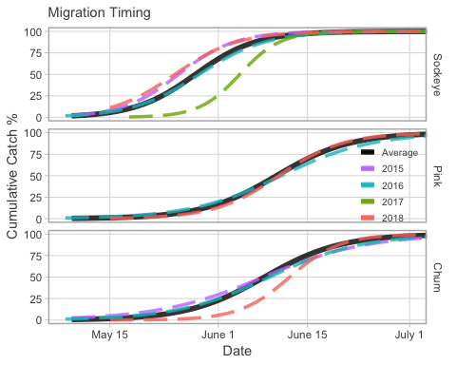

Cumulative abundance of sockeye, pink, and chum, in the Discovery Islands and Johnstone Strait compared to the time series average.

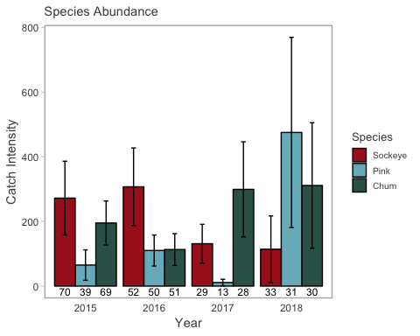

The catch intensity (a measure of abundance) of sockeye, pink, and chum salmon in the Discovery Islands and Johnstone Strait. Numbers under each bar indicate the number of seines in which the species was caught, and erorr bars indicate the 95 percent confidence region.

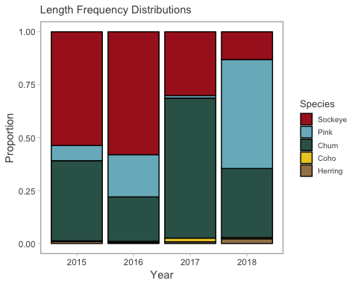

The annual proportion of fish captured in the Discovery Islands and Johnstone Strait combined.

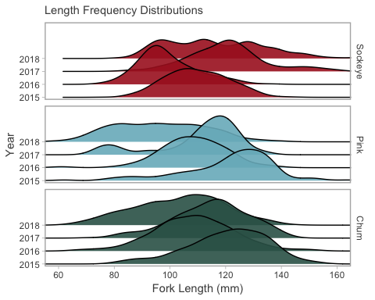

Distributions of juvenile salmon fork lengths for each year in the Discovery Islands and Johnstone Strait. Note that these distributions contain multiple age-classes.

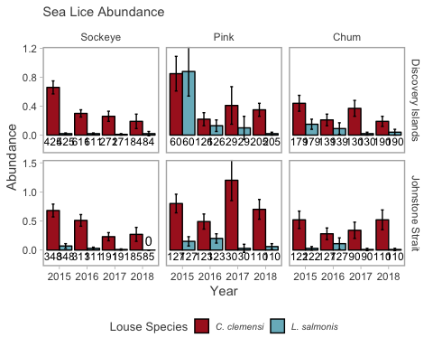

The abundance of motile sea lice on juvenile salmon in the Discovery Islands and Johnstone Strait. The numbers under each bar indicate the sample size and the error bars indicate the 95 percent confidence region.

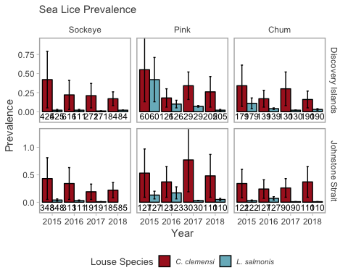

The prevalence of motile sea lice on juvenile salmon in the Discovery Islands and Johnstone Strait. The numbers under each bar indicate the sample size and the error bars indicate the 95 percent confidence region.

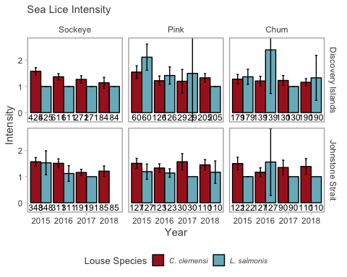

The intensity of motile sea lice on juvenile salmon in the Discovery Islands and Johnstone Strait. The numbers under each bar indicate the sample size and the error bars indicate the 95 percent confidence region.

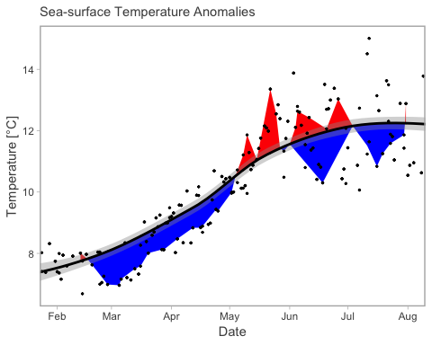

Time series of 30 m depth integrated temperature anomalies observed at Hakai Oceanographic Monitoring station QU39. Blue areas represent temperatures that are below average, red areas represent above average temperatures at the selected station in 2018. Average is the solid black line which is a loess regression based on temperatures from 2015-2018. The shaded grey area is 1 SE of the loess regression. The black dots are the daily minimum and maximum temperatures observed over the time series.

# Tables

(#tab:z-scores-table) Key salmon migration health, growth, and migration parameters standardized to z-scores—the number of standard deviations observations are from the time series average.

|  |  |  |
| --- | --- | --- |
| Year | Parameter | Z-score |
| 2015 | Sockeye Migration Timing | -0.71 |
| 2016 | Sockeye Migration Timing | 0.00 |
| 2017 | Sockeye Migration Timing | 1.41 |
| 2018 | Sockeye Migration Timing | -0.71 |
| 2015 | Sockeye Catch Intensity | 0.68 |
| 2016 | Sockeye Catch Intensity | 1.03 |
| 2017 | Sockeye Catch Intensity | -0.77 |
| 2018 | Sockeye Catch Intensity | -0.94 |
| 2015 | Sockeye Length | -0.20 |
| 2016 | Sockeye Length | -1.32 |
| 2017 | Sockeye Length | 0.94 |
| 2018 | Sockeye Length | 0.58 |
| 2015 | Sockeye Parasite Loads | 1.40 |
| 2016 | Sockeye Parasite Loads | 0.03 |
| 2017 | Sockeye Parasite Loads | -0.69 |
| 2018 | Sockeye Parasite Loads | -0.74 |
| 2015 | Pink Migration Timing | 1.43 |
| 2016 | Pink Migration Timing | -0.16 |
| 2017 | Pink Migration Timing | -0.89 |
| 2018 | Pink Migration Timing | -0.38 |
| 2015 | Pink Catch Intensity | -0.48 |
| 2016 | Pink Catch Intensity | -0.26 |
| 2017 | Pink Catch Intensity | -0.73 |
| 2018 | Pink Catch Intensity | 1.47 |
| 2015 | Pink Length | 1.20 |
| 2016 | Pink Length | -0.09 |
| 2017 | Pink Length | 0.14 |
| 2018 | Pink Length | -1.24 |
| 2015 | Pink Parasite Loads | 0.76 |
| 2016 | Pink Parasite Loads | -1.19 |
| 2017 | Pink Parasite Loads | 0.89 |
| 2018 | Pink Parasite Loads | -0.46 |
| 2015 | Chum Migration Timing | -1.09 |
| 2016 | Chum Migration Timing | 0.06 |
| 2017 | Chum Migration Timing | 1.32 |
| 2018 | Chum Migration Timing | -0.29 |
| 2015 | Chum Catch Intensity | -0.37 |
| 2016 | Chum Catch Intensity | -1.25 |
| 2017 | Chum Catch Intensity | 0.74 |
| 2018 | Chum Catch Intensity | 0.87 |
| 2015 | Chum Length | 1.19 |
| 2016 | Chum Length | -0.44 |
| 2017 | Chum Length | 0.36 |
| 2018 | Chum Length | -1.12 |
| 2015 | Chum Parasite Loads | 1.24 |
| 2016 | Chum Parasite Loads | -1.20 |
| 2017 | Chum Parasite Loads | 0.00 |
| 2018 | Chum Parasite Loads | -0.04 |
| 2015 | SST | -0.04 |
| 2016 | SST | 0.02 |
| 2017 | SST | -1.21 |
| 2018 | SST | 1.23 |
| 2015 | SST | -0.04 |
| 2016 | SST | 0.02 |
| 2017 | SST | -1.21 |
| 2018 | SST | 1.23 |
| 2015 | SST | -0.04 |
| 2016 | SST | 0.02 |
| 2017 | SST | -1.21 |
| 2018 | SST | 1.23 |

(#tab:migration-timing-table) Migration timing statistics for the cumulative catch of sockeye, pink, and chum salmon in the Discovery Islands in 2018, compared to the time-series average (2015 - 2018). Q1 is when 25 % of the species passed through the regions, peak date is the median when 50 % passed through, and Q3 is 75%. The region DI indicates the Discovery Islands while for species SO is sockeye, PI is pink, and CU is chum.

|  |  |  |  |  |  |
| --- | --- | --- | --- | --- | --- |
| Year | Region | Species | Q1 | Peak Date | Q3 |
| 2015 - 2018 | DI | SO | May 26 | May 28 | June 04 |
| 2015 - 2018 | DI | PI | June 07 | June 17 | June 23 |
| 2015 - 2018 | DI | CU | June 06 | June 15 | June 23 |
| 2015 | DI | CU | June 03 | June 05 | June 22 |
| 2015 | DI | PI | June 13 | July 07 | July 07 |
| 2015 | DI | SO | May 23 | May 23 | June 01 |
| 2016 | DI | CU | June 02 | June 15 | June 15 |
| 2016 | DI | PI | June 02 | June 15 | June 15 |
| 2016 | DI | SO | May 24 | May 28 | June 04 |
| 2017 | DI | CU | June 13 | June 26 | July 04 |
| 2017 | DI | PI | June 05 | June 05 | June 26 |
| 2017 | DI | SO | June 05 | June 07 | June 07 |
| 2018 | DI | CU | June 07 | June 12 | June 20 |
| 2018 | DI | PI | June 07 | June 12 | June 12 |
| 2018 | DI | SO | May 23 | May 23 | June 04 |

(#tab:catch-intensity-table) Catch intensity—a measure of inter annual abundance—for sockeye, pink, and chum in the Discovery Islands and Johnstone Strait combined.

|  |  |  |
| --- | --- | --- |
| Year | Species | Catch Intensity |
| 2015 | Chum | 195 |
| 2015 | Pink | 65 |
| 2015 | Sockeye | 272 |
| 2016 | Chum | 113 |
| 2016 | Pink | 110 |
| 2016 | Sockeye | 307 |
| 2017 | Chum | 299 |
| 2017 | Pink | 11 |
| 2017 | Sockeye | 131 |
| 2018 | Chum | 311 |
| 2018 | Pink | 475 |
| 2018 | Sockeye | 114 |

(#tab:length-table) Mean fork lengths for each year, species, and region including the time series average (2015 - 2018), with the 95 % confidence interval (95% CI). The column n indicates the number of fish measured, except for the time series where n indicates the number of years averaged.

|  |  |  |  |  |  |
| --- | --- | --- | --- | --- | --- |
| Year | Region | Species | n | Fork Length (mm) | 95% CI |
| 2015 - 2018 | DI | SO | 4 | 111.0 | 94.6 - 127.4 |
| 2015 - 2018 | DI | PI | 4 | 98.0 | 81.5 - 114.5 |
| 2015 - 2018 | DI | CU | 4 | 105.6 | 93.6 - 117.6 |
| 2015 - 2018 | JS | SO | 4 | 112.3 | 99.4 - 125.2 |
| 2015 - 2018 | JS | PI | 4 | 117.3 | 106.3 - 128.3 |
| 2015 - 2018 | JS | CU | 4 | 119.1 | 110.1 - 128.1 |
| 2015 | DI | SO | 455 | 108.9 | 107.9 - 109.9 |
| 2015 | DI | PI | 47 | 109.6 | 104.1 - 115.1 |
| 2015 | DI | CU | 121 | 115.5 | 112.7 - 118.3 |
| 2015 | JS | SO | 334 | 110.7 | 109.5 - 111.9 |
| 2015 | JS | PI | 98 | 127.1 | 124.9 - 129.3 |
| 2015 | JS | CU | 112 | 126.4 | 124.4 - 128.4 |
| 2016 | DI | SO | 516 | 97.6 | 96.7 - 98.5 |
| 2016 | DI | PI | 96 | 103.9 | 101.3 - 106.5 |
| 2016 | DI | CU | 124 | 103.3 | 100.7 - 105.9 |
| 2016 | JS | SO | 316 | 101.5 | 100.4 - 102.6 |
| 2016 | JS | PI | 94 | 112.6 | 110.7 - 114.5 |
| 2016 | JS | CU | 104 | 115.0 | 112.9 - 117.1 |
| 2017 | DI | SO | 260 | 121.3 | 119.3 - 123.3 |
| 2017 | DI | PI | 17 | 90.9 | 82.3 - 99.5 |
| 2017 | DI | CU | 111 | 106.2 | 103.8 - 108.6 |
| 2017 | JS | SO | 220 | 119.4 | 118 - 120.8 |
| 2017 | JS | PI | 51 | 117.1 | 115.2 - 119 |
| 2017 | JS | CU | 151 | 120.7 | 119.1 - 122.3 |
| 2018 | DI | SO | 84 | 116.2 | 112.6 - 119.8 |
| 2018 | DI | PI | 205 | 87.8 | 86 - 89.6 |
| 2018 | DI | CU | 190 | 97.4 | 95.1 - 99.7 |
| 2018 | JS | SO | 85 | 117.6 | 113.2 - 122 |
| 2018 | JS | PI | 110 | 112.4 | 110.6 - 114.2 |
| 2018 | JS | CU | 110 | 114.2 | 112.4 - 116 |

(#tab:proportion-table) The species proportions of total catch in each year for sockeye, pink, chum, herring, coho, and Chinook.

|  |  |  |  |  |  |
| --- | --- | --- | --- | --- | --- |
| Year | Chum | Coho | Herring | Pink | Sockeye |
| 2015 | 0.378 | 0.003 | 0.009 | 0.072 | 0.537 |
| 2016 | 0.210 | 0.006 | 0.005 | 0.200 | 0.580 |
| 2017 | 0.661 | 0.018 | 0.008 | 0.012 | 0.301 |
| 2018 | 0.326 | 0.006 | 0.022 | 0.515 | 0.131 |

(#tab:sealice-table) Mean sea-lice abundance, prevalence, and intensity (Margolis et al. 1990) for the time series (2015-2018) as well as for each species, region, and year with 95% confidence interval calculated from annual averages. The region DI indicates the Discovery Islands and JS Johnstone Strait. Species codes are SO for sockeye, PI for pink, and CU for chum.

|  |  |  |  |  |  |  |  |
| --- | --- | --- | --- | --- | --- | --- | --- |
| Year | Region | Species | Louse Species | n | Abundance, 95% CI | Prevalence, 95% CI | Intensity, 95% CI |
| 2015 - 2018 | DI | Sockeye | Both Species | 1391 | 0.37 +/- 0.01 | 0.26 +/- 0.01 | 1.37 +/- 0.01 |
| 2015 - 2018 | DI | Sockeye | Motile Caligus | 1391 | 0.35 +/- 0.01 | 0.26 +/- 0.01 | 1.34 +/- 0.01 |
| 2015 - 2018 | DI | Sockeye | Motile Lep | 1391 | 0.02 +/- 0 | 0.02 +/- 0 | 1 +/- 0 |
| 2015 - 2018 | JS | Sockeye | Both Species | 935 | 0.44 +/- 0.02 | 0.31 +/- 0.01 | 1.38 +/- 0.01 |
| 2015 - 2018 | JS | Sockeye | Motile Caligus | 935 | 0.42 +/- 0.01 | 0.3 +/- 0.01 | 1.36 +/- 0.01 |
| 2015 - 2018 | JS | Sockeye | Motile Lep | 935 | 0.03 +/- 0 | NA +/- NA | NA +/- NA |
| 2015 - 2018 | DI | Pink | Both Species | 420 | 0.74 +/- 0.06 | 0.39 +/- 0.02 | 1.7 +/- 0.05 |
| 2015 - 2018 | DI | Pink | Motile Caligus | 420 | 0.46 +/- 0.03 | 0.33 +/- 0.02 | 1.32 +/- 0.02 |
| 2015 - 2018 | DI | Pink | Motile Lep | 420 | 0.28 +/- 0.04 | 0.15 +/- 0.02 | 1.51 +/- 0.04 |
| 2015 - 2018 | JS | Pink | Both Species | 390 | 0.9 +/- 0.02 | 0.58 +/- 0.01 | 1.54 +/- 0.01 |
| 2015 - 2018 | JS | Pink | Motile Caligus | 390 | 0.8 +/- 0.03 | 0.54 +/- 0.02 | 1.47 +/- 0.01 |
| 2015 - 2018 | JS | Pink | Motile Lep | 390 | 0.11 +/- 0.01 | 0.1 +/- 0.01 | 1.12 +/- 0.01 |
| 2015 - 2018 | DI | Chum | Both Species | 638 | 0.37 +/- 0.01 | 0.27 +/- 0.01 | 1.36 +/- 0.01 |
| 2015 - 2018 | DI | Chum | Motile Caligus | 638 | 0.3 +/- 0.01 | 0.24 +/- 0.01 | 1.22 +/- 0 |
| 2015 - 2018 | DI | Chum | Motile Lep | 638 | 0.08 +/- 0 | 0.05 +/- 0 | 1.52 +/- 0.05 |
| 2015 - 2018 | JS | Chum | Both Species | 449 | 0.46 +/- 0.01 | 0.32 +/- 0.01 | 1.39 +/- 0.01 |
| 2015 - 2018 | JS | Chum | Motile Caligus | 449 | 0.42 +/- 0.01 | 0.3 +/- 0.01 | 1.35 +/- 0.01 |
| 2015 - 2018 | JS | Chum | Motile Lep | 449 | 0.04 +/- 0 | 0.03 +/- 0 | 1.14 +/- 0.03 |
| 2015 | DI | Chum | Both Species | 179 | 0.58 +/- 0.14 | 0.4 +/- 0.33 | 1.44 +/- 0.22 |
| 2015 | DI | Pink | Both Species | 60 | 1.73 +/- 0.4 | 0.72 +/- 0.59 | 2.42 +/- 0.4 |
| 2015 | DI | Sockeye | Both Species | 425 | 0.68 +/- 0.09 | 0.43 +/- 0.38 | 1.58 +/- 0.14 |
| 2015 | DI | Chum | Motile Caligus | 179 | 0.44 +/- 0.11 | 0.34 +/- 0.27 | 1.28 +/- 0.18 |
| 2015 | DI | Pink | Motile Caligus | 60 | 0.85 +/- 0.24 | 0.55 +/- 0.42 | 1.55 +/- 0.24 |
| 2015 | DI | Sockeye | Motile Caligus | 425 | 0.66 +/- 0.09 | 0.42 +/- 0.37 | 1.58 +/- 0.14 |
| 2015 | DI | Chum | Motile Lep | 179 | 0.15 +/- 0.07 | 0.11 +/- 0.07 | 1.37 +/- 0.29 |
| 2015 | DI | Pink | Motile Lep | 60 | 0.88 +/- 0.34 | 0.42 +/- 0.29 | 2.12 +/- 0.5 |
| 2015 | DI | Sockeye | Motile Lep | 425 | 0.02 +/- 0.01 | 0.02 +/- 0.01 | 1 +/- 0 |
| 2015 | JS | Chum | Both Species | 122 | 0.55 +/- 0.15 | 0.37 +/- 0.28 | 1.49 +/- 0.23 |
| 2015 | JS | Pink | Both Species | 127 | 0.94 +/- 0.18 | 0.57 +/- 0.48 | 1.64 +/- 0.19 |
| 2015 | JS | Sockeye | Both Species | 348 | 0.74 +/- 0.11 | 0.46 +/- 0.4 | 1.63 +/- 0.16 |
| 2015 | JS | Chum | Motile Caligus | 122 | 0.52 +/- 0.15 | 0.34 +/- 0.26 | 1.5 +/- 0.24 |
| 2015 | JS | Pink | Motile Caligus | 127 | 0.8 +/- 0.16 | 0.53 +/- 0.44 | 1.51 +/- 0.19 |
| 2015 | JS | Sockeye | Motile Caligus | 348 | 0.68 +/- 0.11 | 0.43 +/- 0.38 | 1.57 +/- 0.16 |
| 2015 | JS | Chum | Motile Lep | 122 | 0.03 +/- 0.03 | 0.03 +/- 0.01 | 1 +/- 0 |
| 2015 | JS | Pink | Motile Lep | 127 | 0.15 +/- 0.08 | 0.13 +/- 0.07 | 1.19 +/- 0.29 |
| 2015 | JS | Sockeye | Motile Lep | 348 | 0.07 +/- 0.04 | 0.04 +/- 0.02 | 1.53 +/- 0.46 |
| 2016 | DI | Chum | Both Species | 139 | 0.29 +/- 0.13 | 0.19 +/- 0.13 | 1.52 +/- 0.44 |
| 2016 | DI | Pink | Both Species | 126 | 0.36 +/- 0.13 | 0.24 +/- 0.17 | 1.5 +/- 0.25 |
| 2016 | DI | Sockeye | Both Species | 611 | 0.31 +/- 0.05 | 0.23 +/- 0.2 | 1.37 +/- 0.12 |
| 2016 | DI | Chum | Motile Caligus | 139 | 0.21 +/- 0.08 | 0.17 +/- 0.11 | 1.21 +/- 0.18 |
| 2016 | DI | Pink | Motile Caligus | 126 | 0.22 +/- 0.09 | 0.18 +/- 0.12 | 1.22 +/- 0.18 |
| 2016 | DI | Sockeye | Motile Caligus | 611 | 0.3 +/- 0.05 | 0.22 +/- 0.19 | 1.37 +/- 0.12 |
| 2016 | DI | Chum | Motile Lep | 139 | 0.09 +/- 0.08 | 0.04 +/- 0.01 | 2.4 +/- 1.67 |
| 2016 | DI | Pink | Motile Lep | 126 | 0.13 +/- 0.08 | 0.1 +/- 0.05 | 1.42 +/- 0.33 |
| 2016 | DI | Sockeye | Motile Lep | 611 | 0.02 +/- 0.01 | 0.02 +/- 0.01 | 1 +/- 0 |
| 2016 | JS | Chum | Both Species | 127 | 0.39 +/- 0.15 | 0.28 +/- 0.21 | 1.36 +/- 0.37 |
| 2016 | JS | Pink | Both Species | 123 | 0.68 +/- 0.15 | 0.49 +/- 0.4 | 1.4 +/- 0.17 |
| 2016 | JS | Sockeye | Both Species | 311 | 0.54 +/- 0.1 | 0.35 +/- 0.3 | 1.53 +/- 0.17 |
| 2016 | JS | Chum | Motile Caligus | 127 | 0.28 +/- 0.1 | 0.24 +/- 0.17 | 1.17 +/- 0.17 |
| 2016 | JS | Pink | Motile Caligus | 123 | 0.49 +/- 0.13 | 0.37 +/- 0.28 | 1.33 +/- 0.16 |
| 2016 | JS | Sockeye | Motile Caligus | 311 | 0.51 +/- 0.1 | 0.34 +/- 0.29 | 1.51 +/- 0.17 |
| 2016 | JS | Chum | Motile Lep | 127 | 0.11 +/- 0.1 | 0.07 +/- 0.03 | 1.56 +/- 1.28 |
| 2016 | JS | Pink | Motile Lep | 123 | 0.2 +/- 0.08 | 0.17 +/- 0.11 | 1.14 +/- 0.16 |
| 2016 | JS | Sockeye | Motile Lep | 311 | 0.03 +/- 0.02 | 0.03 +/- 0.01 | 1.12 +/- 0.3 |
| 2017 | DI | Chum | Both Species | 130 | 0.38 +/- 0.11 | 0.32 +/- 0.24 | 1.22 +/- 0.18 |
| 2017 | DI | Pink | Both Species | 29 | 0.52 +/- 0.33 | 0.34 +/- 0.18 | 1.5 +/- 0.61 |
| 2017 | DI | Sockeye | Both Species | 271 | 0.28 +/- 0.07 | 0.22 +/- 0.17 | 1.25 +/- 0.13 |
| 2017 | DI | Chum | Motile Caligus | 130 | 0.37 +/- 0.11 | 0.3 +/- 0.22 | 1.23 +/- 0.19 |
| 2017 | DI | Pink | Motile Caligus | 29 | 0.41 +/- 0.26 | 0.34 +/- 0.18 | 1.2 +/- 0.45 |
| 2017 | DI | Sockeye | Motile Caligus | 271 | 0.26 +/- 0.07 | 0.21 +/- 0.16 | 1.27 +/- 0.14 |
| 2017 | DI | Chum | Motile Lep | 130 | 0.02 +/- 0.02 | 0.02 +/- 0 | 1 +/- 0 |
| 2017 | DI | Pink | Motile Lep | 29 | 0.1 +/- 0.16 | 0.07 +/- 0.01 | 1.5 +/- 6.35 |
| 2017 | DI | Sockeye | Motile Lep | 271 | 0.01 +/- 0.01 | 0.01 +/- 0 | 1 +/- 0 |
| 2017 | JS | Chum | Both Species | 90 | 0.36 +/- 0.14 | 0.27 +/- 0.18 | 1.33 +/- 0.27 |
| 2017 | JS | Pink | Both Species | 30 | 1.23 +/- 0.35 | 0.77 +/- 0.58 | 1.61 +/- 0.31 |
| 2017 | JS | Sockeye | Both Species | 191 | 0.23 +/- 0.07 | 0.2 +/- 0.14 | 1.16 +/- 0.12 |
| 2017 | JS | Chum | Motile Caligus | 90 | 0.34 +/- 0.14 | 0.26 +/- 0.17 | 1.35 +/- 0.28 |
| 2017 | JS | Pink | Motile Caligus | 30 | 1.2 +/- 0.35 | 0.77 +/- 0.58 | 1.57 +/- 0.31 |
| 2017 | JS | Sockeye | Motile Caligus | 191 | 0.23 +/- 0.07 | 0.19 +/- 0.14 | 1.16 +/- 0.12 |
| 2017 | JS | Chum | Motile Lep | 90 | 0.01 +/- 0.02 | 0.01 +/- 0 | 1 +/- NA |
| 2017 | JS | Pink | Motile Lep | 30 | 0.03 +/- 0.07 | 0.03 +/- 0 | 1 +/- NA |
| 2017 | JS | Sockeye | Motile Lep | 191 | 0.01 +/- 0.01 | 0.01 +/- 0 | 1 +/- NA |
| 2018 | DI | Chum | Both Species | 190 | 0.23 +/- 0.08 | 0.18 +/- 0.13 | 1.26 +/- 0.21 |
| 2018 | DI | Pink | Both Species | 205 | 0.37 +/- 0.09 | 0.27 +/- 0.21 | 1.36 +/- 0.16 |
| 2018 | DI | Sockeye | Both Species | 84 | 0.21 +/- 0.12 | 0.17 +/- 0.09 | 1.29 +/- 0.35 |
| 2018 | DI | Chum | Motile Caligus | 190 | 0.19 +/- 0.07 | 0.16 +/- 0.11 | 1.16 +/- 0.14 |
| 2018 | DI | Pink | Motile Caligus | 205 | 0.35 +/- 0.09 | 0.26 +/- 0.2 | 1.33 +/- 0.16 |
| 2018 | DI | Sockeye | Motile Caligus | 84 | 0.19 +/- 0.1 | 0.17 +/- 0.09 | 1.14 +/- 0.21 |
| 2018 | DI | Chum | Motile Lep | 190 | 0.04 +/- 0.04 | 0.03 +/- 0.01 | 1.33 +/- 0.86 |
| 2018 | DI | Pink | Motile Lep | 205 | 0.02 +/- 0.02 | 0.02 +/- 0.01 | 1 +/- 0 |
| 2018 | DI | Sockeye | Motile Lep | 84 | 0.02 +/- 0.03 | 0.02 +/- 0 | 1 +/- 0 |
| 2018 | JS | Chum | Both Species | 110 | 0.53 +/- 0.17 | 0.38 +/- 0.29 | 1.38 +/- 0.29 |
| 2018 | JS | Pink | Both Species | 110 | 0.76 +/- 0.18 | 0.5 +/- 0.4 | 1.53 +/- 0.23 |
| 2018 | JS | Sockeye | Both Species | 85 | 0.27 +/- 0.12 | 0.22 +/- 0.14 | 1.21 +/- 0.2 |
| 2018 | JS | Chum | Motile Caligus | 110 | 0.52 +/- 0.17 | 0.37 +/- 0.28 | 1.39 +/- 0.3 |
| 2018 | JS | Pink | Motile Caligus | 110 | 0.7 +/- 0.17 | 0.48 +/- 0.39 | 1.45 +/- 0.2 |
| 2018 | JS | Sockeye | Motile Caligus | 85 | 0.27 +/- 0.12 | 0.22 +/- 0.14 | 1.21 +/- 0.2 |
| 2018 | JS | Chum | Motile Lep | 110 | 0.01 +/- 0.02 | 0.01 +/- 0 | 1 +/- NA |
| 2018 | JS | Pink | Motile Lep | 110 | 0.06 +/- 0.05 | 0.05 +/- 0.02 | 1.17 +/- 0.43 |
| 2018 | JS | Sockeye | Motile Lep | 85 | 0 +/- 0 | NA +/- NA | NA +/- NA |

(#tab:sst-table) 30 m depth integrated temperature averages from May to the end of June in the Northern Strait of Georgia station QU39.

|  |  |
| --- | --- |
| Year | Temperature (C) |
| 2015 | 11.55 |
| 2016 | 11.56 |
| 2017 | 11.28 |
| 2018 | 11.84 |

# References

Beamish, R., and C. Mahnken. 2001. “A critical size and period hypothesis to explain natural regulation of salmon abundance and the linkage to climate and climate change.” *Progress in Oceanography* 49: 423–37.

Beamish, R., C. Neville, R. Sweeting, and K. Lange. 2012. “The synchronous failure of juvenile pacific salmon and herring production in the strait of georgia in 2007 and the poor return of sockeye salmon to the Fraser river in 2009.” *Marine and Coastal Fisheries* 4 (1): 403–14. doi:[10.1080/19425120.2012.676607](https://doi.org/10.1080/19425120.2012.676607).

Chandler, P.C., S.A. King, and J. Boldt. 2017. “State of the Physical , Biological and Selected Fishery Resources of Pacific Canadian Marine Ecosystems in 2016 Can. Tech. Rep. Fish. Aquat. Sci.” 3225 (243). Sidney, BC: Fisheries; Oceans Canada.

Heard, William R. 1991. “Life History of Pink Salmon.” In *Pacific Salmon Life Histories*, edited by C. Groot and L. Margolis, 121. 2029 West Mall, Vancouver, BC V6T 1Z2: UBC Press.

Hunt, Brian P.V., Brett T. Johnson, Sean C. Godwin, Martin Krkošek, Evgeny A Pakhomov, and Luke A Rogers. 2018. “The Hakai Institute Juvenile Salmon Program : Early Life History Drivers of Marine Survival in Sockeye , Pink and Chum Salmon in British Columbia.” Institute for the Oceans; Fisheries; Department of Earth, Ocean; Atmospheric Sciences, University of British Columbia, Hakai Institute, Earth to Ocean Research Group, Simon Fraser University, Department of Ecology; Evolutionary Biology, Univer.

Margolis, L., G. W. Esch, A.M. Kuris, and G.A. Schad. 1990. “The Use of Ecological Terms in Parasitology (Report of an Ad Hoc Committee of the American Society of Parasitologists).” *The Journal of Parisitology* 68 (1): 131–33. doi:[10.2307/3281335](https://doi.org/10.2307/3281335).

Patanasatienkul, Thitiwan, Javier Sanchez, Erin E. Rees, Martin Krkošek, Simon R.M. Jones, and Crawford W. Revie. 2013. “Sea lice infestations on juvenile chum and pink salmon in the Broughton Archipelago, Canada, from 2003 to 2012.” *Diseases of Aquatic Organisms* 105 (2): 149–61. doi:[10.3354/dao02616](https://doi.org/10.3354/dao02616).

Peterman, Randall M, D Marmorek, B Beckman, M Bradford, M Lapointe, N Mantua, Brian Riddell, et al. 2010. “Synthesis of evidence from a workshop on the decline of Fraser River sockeye. June 15-17, 2010. A Report to the Pacific Salmon Commission.” August. Vancovuer, British Columbia: Pacific Salmon Commission.

R Core Team. 2017. *R: A Language and Environment for Statistical Computing*. Vienna, Austria: R Foundation for Statistical Computing. <https://www.R-project.org/>.